Ilia Trefilov

# User Experience – Visual Diary **AS 91901**

Contents

User Experience – Visual Diary **AS 91901** 1

What Is User Experience? 5

User Experience Methodologies 6

User Surveys 6

Competitive Analysis 6

User Personas 7

Journey Mapping 8

Card Sorting 9

Empathy Mapping 10

Stakeholder Questions & Answers 11

Brief 11

Specifications 11

Gut Test 11

Applying UX Methodologies 11

Competitive Analysis 11

User Personas 13

Persona 1: Janice Ropeman 13

Persona 2: Zoe Corbin 14

Card Sorting 14

Cart Sort 1 15

Card Sort 2 15

Site map 16

Low-Fidelity Wireframes 16

Iteration 1 17

Iteration 2 18

Iteration 3 19

Iteration 4 – Final 20

Home Page 20

Club Info Page 21

Classes Page 22

Competition Info Page 23

Gallery Page 24

Sponsors Page 25

Contacts Page 26

Mobile Wireframes 26

Home Page 27

Club Info Page 28

Classes Page 29

Competition Info Page 30

Gallery Page 31

Sponsors Page 32

Contacts Page 33

Design Tiles 34

Design Tiles 1 34

Design Tiles 2 35

Feedback 36

High-Fidelity Wireframes 36

Home Page 37

Club Info Page 38

Classes Page 39

Competition Info Page 40

Gallery Page 41

Sponsors Page 42

Contacts Page 43

Mobile High Fidelity 43

Home Page 44

Club Info Page 45

Classes Page 46

Competition Info Page 47

Gallery Page 48

Sponsors Page 49

Contacts Page 50

Relevant Implications 51

Legal 51

Privacy 51

Usability 51

Evaluation 52

Stakeholder Questions 52

Gut Test 52

Competitive Analysis 52

User Personas 52

Card Sort 52

Other UX methodologies 53

Design Tiles 53

Wireframes 53

Overall Evaluation 53

Future Developments 53

End-User Consideration 54

# What Is User Experience?

User experience (UX) is the study of how a user interacts with your digital product and their experience. The end goal of UX is to make a product that feels good and intuitive to use and makes the users have a good experience with your product. Some things that should be taken into consideration when thinking about UX is how you can improve accessibility, usability, readability, and general feel of your product.

There are 3 different stages of UX. The first one is the user research stage. Here you discover what type of digital product you will be making (e.g. website, program, game), why you are making it, and who the stakeholder and the future users are. There are a few UX methods that help with answering these questions, them being:

* Stakeholder Questions
* User Interviews
* Field Studies

All of these methods involve asking lots of questions to the future users and the stakeholder. The next stage is the design stage. Here you design the website and figure out what you need. Most of this stage is thinking how the user will interact with your product and what they might have trouble with. The UX methods someone might use during this stage are:

* Competitive Analysis
* User Personas
* Journey Mapping
* Card Sorting

All of these methods help with thinking of ways to improve your website so that it’s easier to use. The next stage is testing. During this stage you should test every part of your website. Every button should lead you to where they are meant to, all pictures show up in the correct size, and everything works how the user expects it does. The UX methods you could use during the stage are:

* Excessive Testing
* User Testing
* Accessibility Testing

It’s important to make sure your product is accessible to unexperienced users and people with impaired senses. The final stage is listening. During this stage you should be done with a basic version of your product. The main focus of this phase is to get feedback from your users and stakeholder to improve your product. Some methods that one can use to do this are:

* Check Bug Reports
* Stakeholder/User Questions
* Analytics Analysis
* Empathy Mapping

It’s important to remember that since UX is an iterative process, all these methodologies can be used whenever you think they are beneficial, the way I listed them is just a rough outline for how your UX journey should look. You also don’t have to use all of these methods. You should pick and choose what methods you use based on effectiveness, time limit, and budget.

<https://careerfoundry.com/en/blog/ux-design/the-ux-design-process-an-actionable-guide-to-your-first-job-in-ux/>

# User Experience Methodologies

## User Surveys

User Surveys are an easy way to see what aspects of the site users like and what they don’t. User surveys usually include a big list of questions about aspects of the website that can provide insight on what users like and what users don’t. The questions can ask about the website or the user themselves to see if they are part of the target audience and if you should take their feedback more serious than others. The answers to these questions help the designer and stakeholder see what parts of the website need to be worked on.

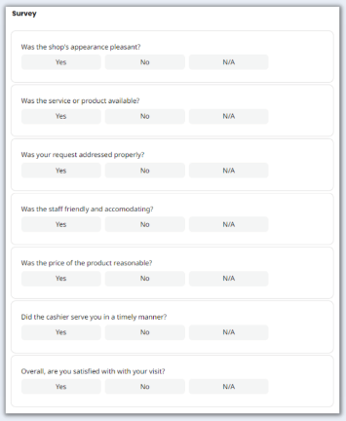Image source:  
<https://safetyculture.com/checklists/customer-satisfaction-surveys/>

**P**r**os**:

* It can be made easily in google forms or some website made for user surveys.
* Depending on how many questions there are, a survey can be finished in a few minutes. They are the best way to get lots of feedback in a short time.
* When users are anonymous/answering a survey, they tend to give harsher/better feedback than if they were talking were talking to someone.
* It’s easy to send out to lots of users

Cons:

* Some people won’t answer them honestly.
* Users who are likely to do a user survey are the ones that really like the website or ones that really hate it. Without forcing people to do a user survey before they can access the site, there is no way to get a true opinion on your website by the average user. However, if it is forced, then most users will put in random answers to be able to access the site.
* Depending on how in-depth the user answers, the results might vary in how useful they are

## Competitive Analysis

Competitive analysis is a research method where you analyse competitors’ sites and compare the strengths and weaknesses in their user experience. You should start this by looking at websites that aim to do the accomplish the same goal as you and analyse what they do right and wrong. Next you could ask your stakeholder to look at competitors’ sites and tell you what they like about them. Next you could broaden the website you look at, start looking at websites that only partially focus on what you look to achieve, or websites that have similar users to yours (e.g. if you are making a website to sell golf gear, look at other websites that focus around golf). In the end you should have a list of items that you should and shouldn’t use on your website.

Pros:

* Much easier and faster than coming up with your own ideas. This lets you spend more time making those ideas better/unique
* Provides a benchmark to see if your design is good or not
* Can provide inspiration for your website design

Cons:

* Might result in similar designs. Some people might struggle to make their own design when using aspects of other websites
* Looking at competitor sites might discourage you

## User Personas

User personas entail making a fictional persona that is similar to a typical user of your site. These personas should be based on interviews, user surveys, or people your stakeholder knows. The advantage of doing this is that the designer can truly understand the person that would use this website. The best user personas use stereotyping so that it’s easier to feel like you know the person and how to design for them. If a user persona is an old looking person who you know to make a website that even someone who knows nothing about websites can use it.

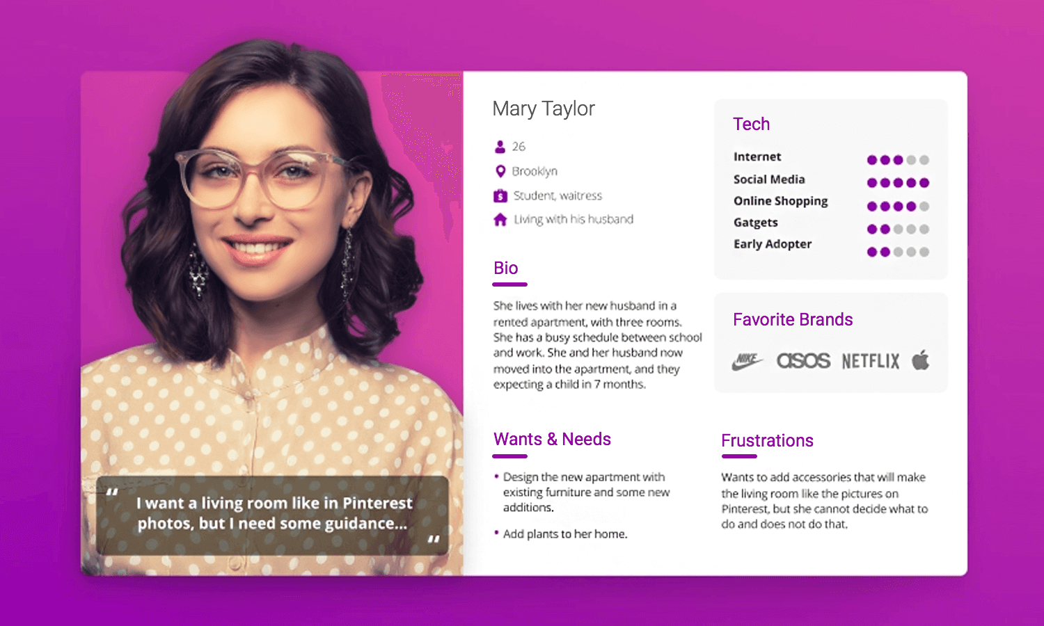  
Source: <https://www.justinmind.com/blog/user-persona-templates/>

When creating a user persona, you should look at future users of your website. If the stakeholder already has a business but no website, you should talk to some of the clients to get some data on the average future user. From the data you have received you should combine all of it and create 2 to 5 user personas. What the personas entail is up to you, however it’s a good idea to have the following;

* A section about them. This section should include their name, age, location, hobbies, and occupation
* A bio that tells you about the user. This should include more in-depth info about the stuff from the “about them” section and other interesting info to make them seem like a real person
* The user’s wants and needs/goals.
* Their frustrations with websites, themselves, or life itself. Pretty much just a list of things that you should prevent, and stuff to not include in your website.
* Their knowledge about the internet. Not needed but it’s nice to include what aspects of the internet they know how to use instead of just implying it.
* A basic bit about their personality, if they are introverted, extroverted, problem solver, or someone who gives up quickly, stuff like that.

Pros:

* Builds a deep understanding of the future users
* Easy and effective way to display data about what your websites needs to do and what to avoid
* Sets a simple goal

Cons:

* Involves some stereotyping that can come of an offensive to some
* Doesn’t work well if your user base has a large variety of users
* Your user personas might not be anything like you actual users
* Can take up lots of time, especially talking to real people

## Journey Mapping

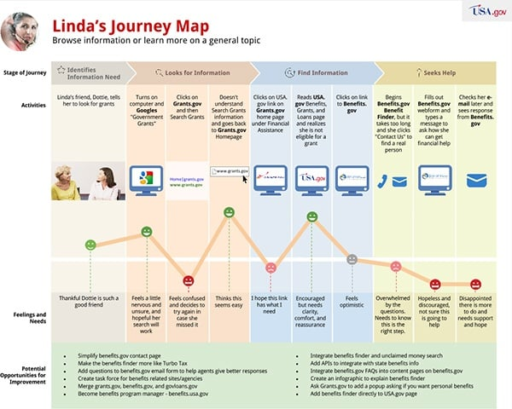

Source: <https://blog.usa.gov/journey-mapping-our-customer-experience>

A journey map documents the journey a user persona will take to achieve their goal and how they interact with your product to achieve it. There are 4 stages to a user’s journey, they are:

* Discover stage
* Learning stage
* Use stage
* Decide stage

The first stage is the discover stage. Here you write how the user found out about the website. Some common ways are; advertisements, word from a friend, googling website for their need online. During the learning stage the user learns how to access your product. Usually by downloading it or opening it on google if it’s a website. During the use stage the user uses your product. Here you have to make up ways that the user persona will interact with the website and what troubles they will face when trying to achieve their goal. The final stage is the decide stage. Here the user decides what they do with your product. Usually if it’s a website they either decide to buy something, leave the website out of anger or confusion, or they save it in their mind to use it later.  
While making a journey map you have to use on of your user personas and detail how they go through those 4 stages. You have to make up what they like and what annoyances they have. Somewhere you should also include ways that you can make your website better and make their journey more pleasurable.  
The problem with journey mapping is it’s all made up. Thinking about a user’s journey is really important but actually making it into a diagram will heavily vary in usefulness. If you have a huge team (in the tens or the hundreds) this is a nice and clear way to show possible annoyances and how to fix them, however, for solo developers and small teams it would be better to just write down the annoyances and the solution in a separate document and not bother with making a diagram, saving you lots of time that you can spend on improving your product.

Pros:

* In-depth way to show what parts of a user’s journey the user will have trouble with
* Really helpful to think about
* Would work way better for testing early version than for designing user experience

Cons:

* Huge waste of time to make a diagram
* What you expect to be a fix for an annoyance could do the opposite
* You can easily miss annoyances that you haven’t considered
* Not documenting real users

## Card Sorting

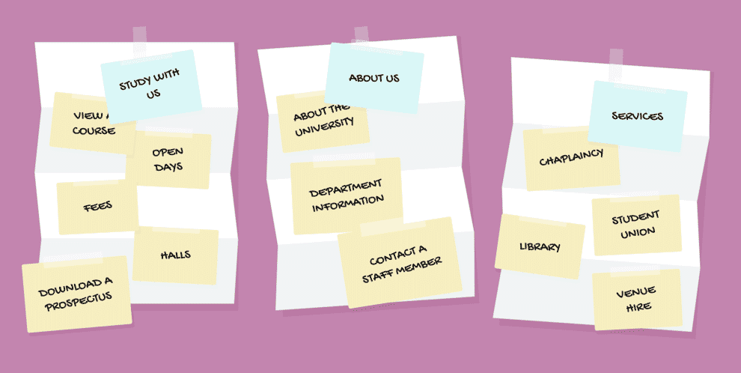

Source: <https://boagworld.com/usability/card-sorting/>

Card sorting is a process that lets you discover what information users categorize together. This involves giving users a bunch of pieces of papers/cards and then letting them sort the cards into groups that make sense. There are 3 different types of card sorts. The first one is a Closed card sort; this means that you give the users categories and let them sort the cards into those fixed categories. An Open card sort involves not giving the user any categories and letting them sort the cards and making them write the categories at the end. The last type is a hybrid, this one involves giving the users fixed categories and making them sort the cards into those categories, however, they have the freedom to add their own categories if they feel it is necessary. Card sorting should be done pretty early in development to determine what information you categorize together. Card sorting will be helpful when making a site map and wire frames later on.

Pros:

* Let’s users feel helpful and like they were part of the final product, making them more likely to be long time users.
* Pretty quick to do and can be re used on lots of different people.
* Gives insight on how users will look for information on your final product.
* Makes a site map much easier to make.
* Can be done online. Doesn’t even require you to call, you can send them a link to a website, and they can send you a picture of their results.

Cons:

* Neurodivergent people think differently. They might try find and categorize information in different parts than a non-neurodivergent person.
* Categorization is subjective to that individual person.

## Empathy Mapping

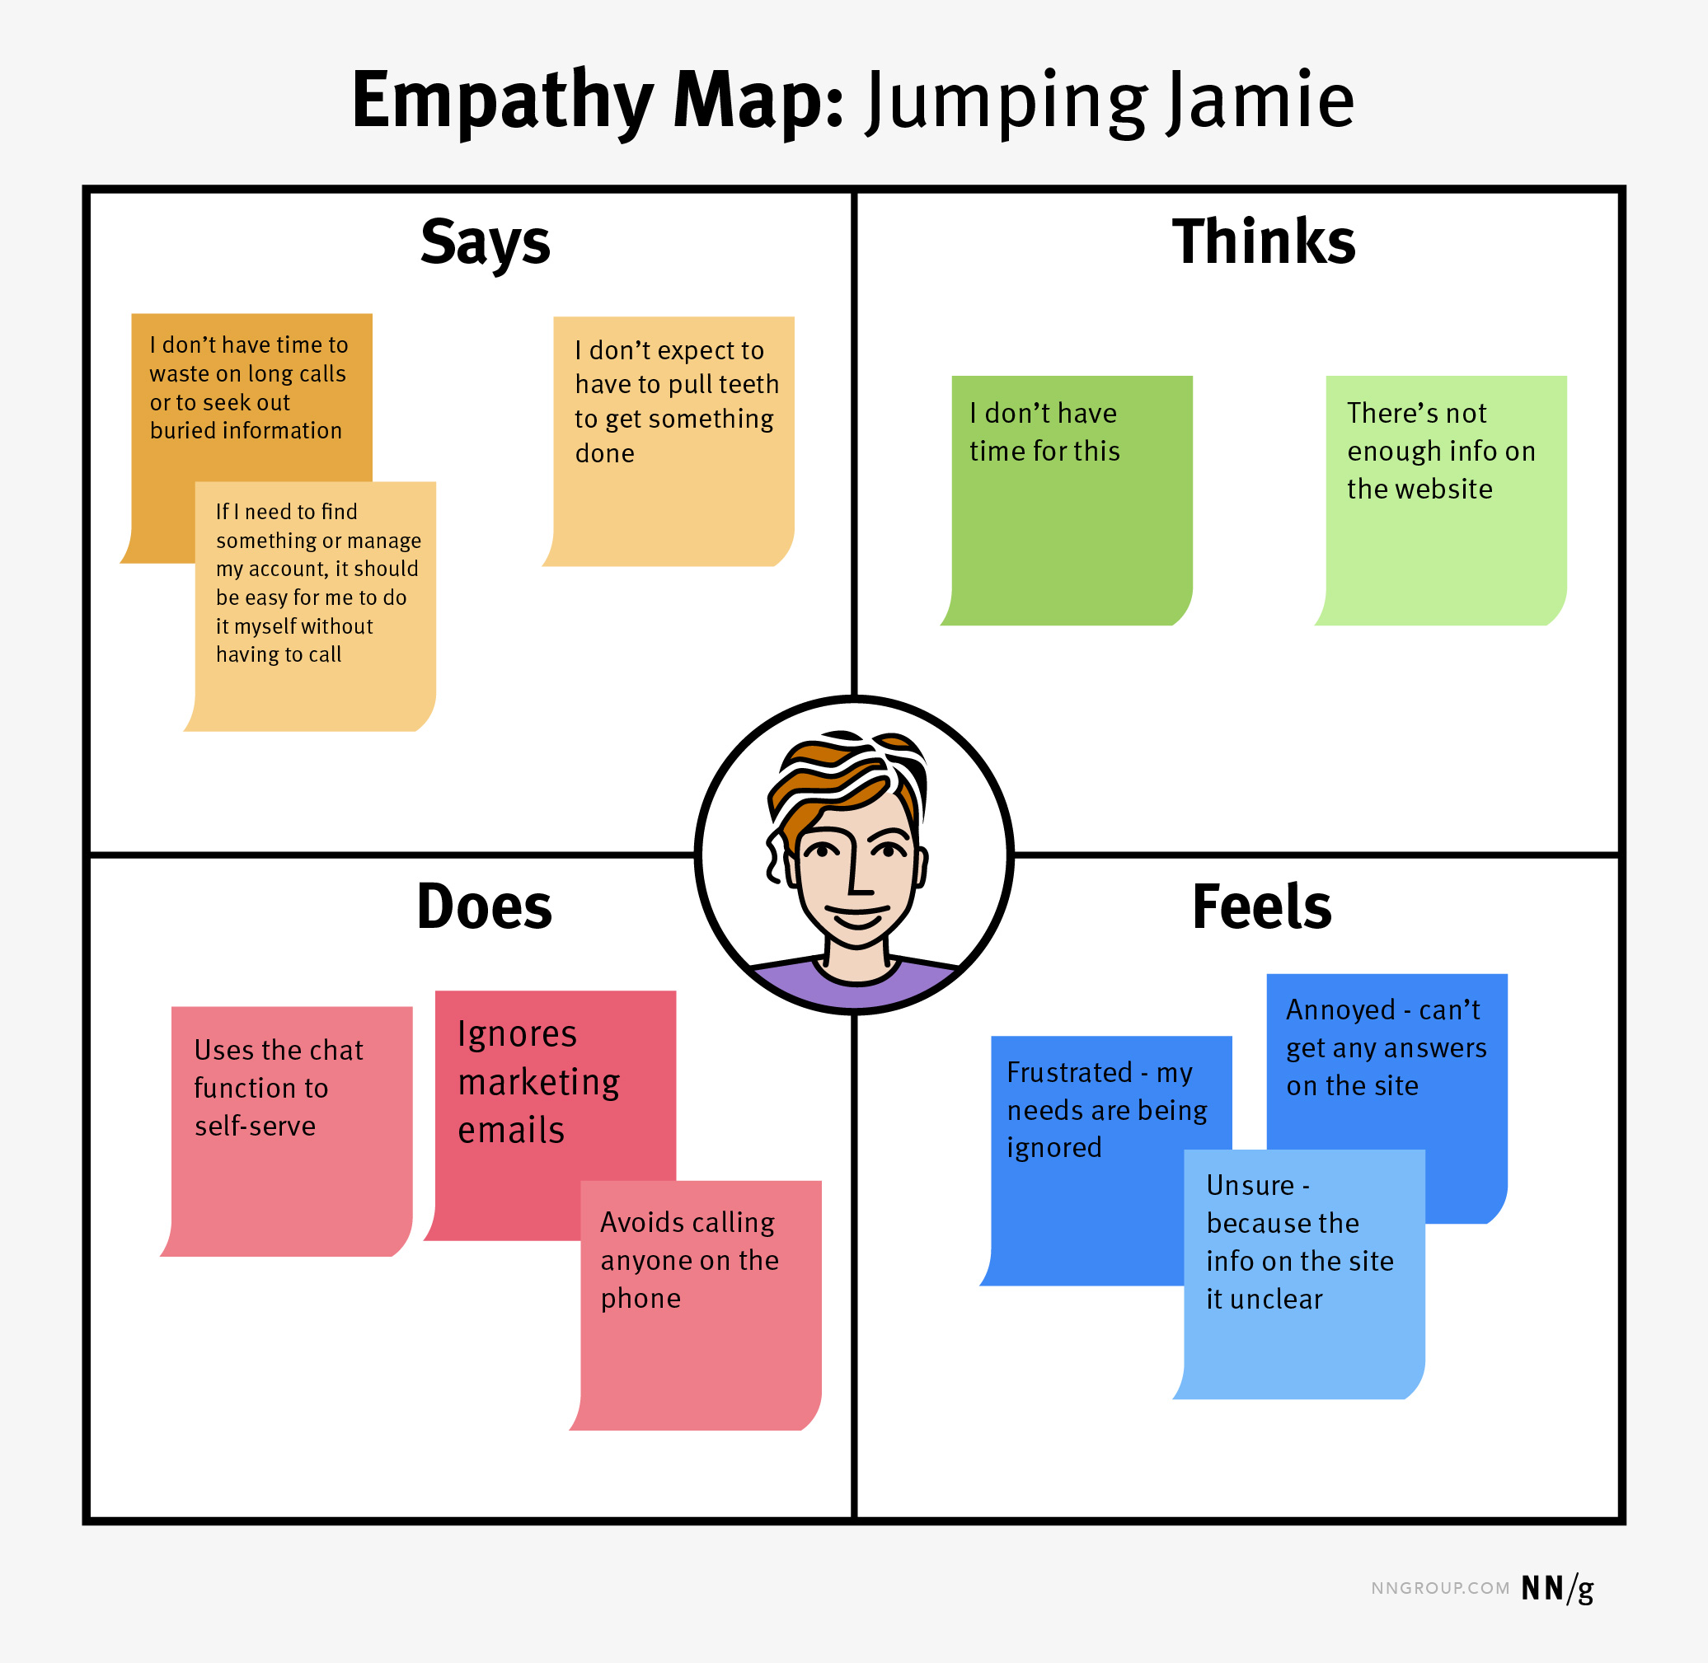

Source: <https://www.nngroup.com/articles/using-empathy-maps/>

Another methodology that requires thinking about your user personas and laying out the same information slightly differently. Empathy maps are a way to show how the user feels, thinks, does, and says. There is usually a picture of the user in the middle and there’s 4 quadrants around it each having their own theme. The usual themes that you should include are:

* Says. What type of things the user would say when using your product.
* Thinks. What the user thinks about when using your product. Also, what the user thinks about your product and the experience.
* Does. How the user uses your product and/or how they typically use similar products.
* Feels. How the user feels about the product and experience.

The usefulness of this applies depending on when you do it. Some people say that you should use this during the design stage because it could be useful for designing your website. The problem with doing it at the start is that you have to do this with a user persona. Like journey mapping, it’s important to think of these things before you start making your website but everything being made up and not 100% accurate takes away from usefulness. In my opinion it’s better to do an empathy map when you are getting feedback on your website. These fields being filled in with responses filled in by actual users can be a useful bit of insight on how to improve your product for the final release.

Pros:

* Simple and effective way to show “feedback” and thoughts on website.
* Simple to make and won’t require much time.

Cons:

* Heavily fluctuates in usefulness depending on when it’s done.
* If done with a user persona, everything is made up by you. Your made-up thoughts might not correspond with actual users (could lead to making website worse).

# Stakeholder Questions & Answers



# Brief

Waitemata Synchro Club is a club that teaches kids how to do synchronized swimming. My client is Daria Trefilova, a coach at the club. They need a website to increase their presence, have a way to share photos with parents and club members, and a way to show their sponsors. Their main demographic is kids and teens (8-21yrs) and parents of children/teens (35-50yrs). Another use for the website would be to make it easier to sign up for classes. A successful website would result in more people signing up for classes and them getting more online presence.

# Specifications

* Pages Needed:
  + Home page
  + Club Info Page
  + Classes Page
  + Competition Info Page
  + Gallery Page
  + Sponsors Page
  + Contacts Page
* Colour scheme that has blue
* Not much filler and lots of useful information
* Usable by people with vision impairment
* Lots of pictures
* Easy to use navigation bar.

# Gut Test

A gut test is a collection of screenshots from websites that I then show to my client to see what she likes and doesn’t. It’s explained more inside the powerpoint.



# Applying UX Methodologies

## Competitive Analysis

|  |  |  |  |  |
| --- | --- | --- | --- | --- |
|  | Aspire Gymnastics | Northern Arena | North Harbour Synchro | Bay Olympic Girls Football |
| Design | White website with a secondary purple colour. Most of the website is white with a few lines of black text. The website feels a little empty put is pretty good at conveying info. | Has a colour scheme of black, white, and blue. The website used a lot of pictures to make the pages longer and feel less empty. For some reason the website is split into 2 parts so that is really bad for conveying info. | White website with a secondary red colour. Most pages have enough text and pictures to not make it feel too empty, some pages do this better than others though. | Has a colour scheme of black, white, and green. This website uses colours really well, especially on the home page which looks really good, even including black, red, and blue. This site does not feel empty as they used text and pictures very wisely. |
| Option to sign up for lessons online | Yes | Yes | Yes | Yes |
| Contact Form | Yes | No | Yes | Yes |
| Social Media Links in Header | No | No | No | Yes |
| Way to sign up / log in | No | Yes | Yes | Yes |
| News page where you can click on articles to make them bigger | No new page | Yes, news tab is hidden and hard to find though | Yes | Yes |
| Map with location | No | Yes | Yes, but I couldn’t use it and it was just a blank grey rectangle | Yes |
| Gallery | Yes | No, there might be one hidden somewhere but the way info is displayed is really badly and I couldn’t find one | Yes | Yes |
| Info about coaches | Yes | Yes, only pictures and their names though | Yes, only pictures and their names though | No, might be one but I couldn’t find one |
| Sponsors page | No, I don’t think they have any sponsors in general though | No, I don’t know if they have any sponsors though | Yes | Yes |

The purpose of doing competitive analysis was to see what our competitor’s websites look like. I used 4 websites that have a similar goal of cultivating a club for a sport, not necessarily just artistic swimming. I made a table and wrote down and colour coded all the information so it’s easier to consume in a glance. This information will be helpful in making my website as I can refer back to it and see what features I should add.

While doing this competitive analysis I also managed to look at the design of the websites and the way they laid out their pages and information. The gymnastics and North Harbour synchro clubs had a small number of pages with not much filler text, but a lot of their pages were empty/white and the sites looked a little sad. Northern Arena and Bay Olympic girls had a really good design and used colour effectively, but they had a huge number of pages and I didn’t know what pages to look at to find certain stuff. Norther Arena was especially bad at this having 2 different websites based on if you are a member or not, and having lots of stuff hidden not and not accessible in their navigation tab.

## User Personas

Too make my user personas I used Lucid Spark. I chose this website because it is free, unlike a lot of other websites who claim to be “free” but then ask for a subscription, and because I have used it last year to make a mind map and liked the UI and the UX. Before making these user personas, I went to one of my stakeholder’s coaching sessions and observed the people who came and talk with a few people. Most of the people who came were either kids, or their parents who picked them up. However, there were a few moms who were doing artistic swimming with their kids for fun.

### Persona 1: Janice Ropeman

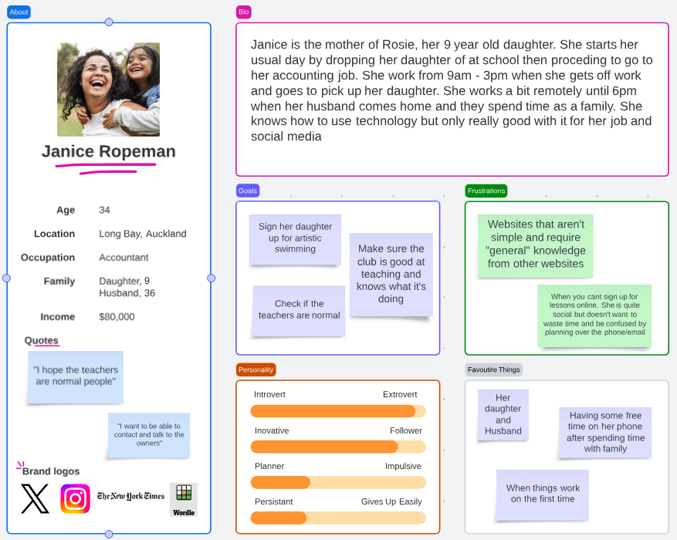

For my first persona I made someone who represents our main demographic. Janice Ropeman is a mother whose daughter wants to do synchronized swimming. She will use our website to sign her daughter up and to check out the organization to make sure it’s not dodgy.

Making this user persona has helped me understand that I need to design a website that looks friendly, safe, yet authentic and believable. If we make a site that looks like it’s trying to be too friendly, then it might scare of parents who start to think this is a scam.

### Persona 2: Zoe Corbin

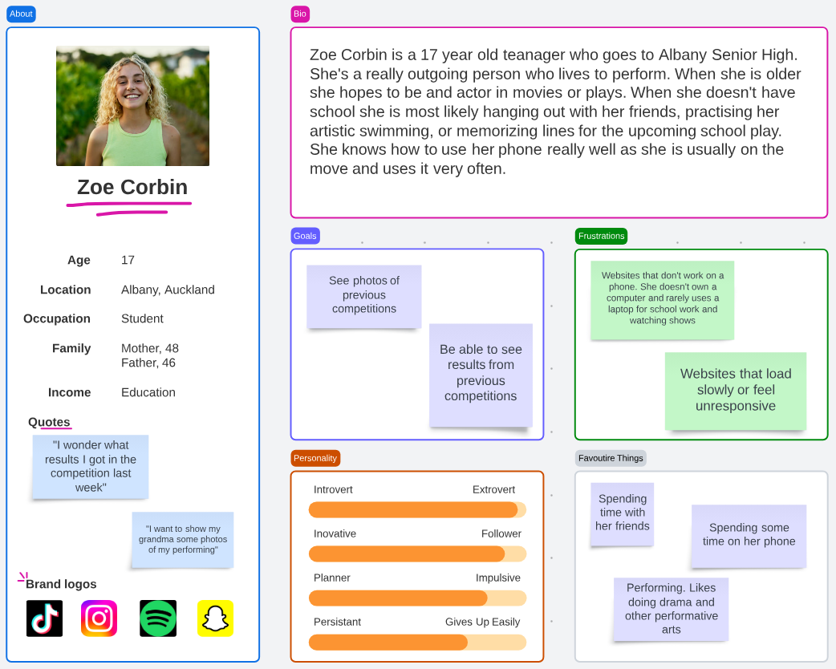

My second persona is the other half of our main demographic, the people who do the synchronized swimming. Zoe Corbin does artistic swimming and will use the website to show pictures to her grandparents and to be able to see what place she placed in competitions.

Making this user persona helped me understand that I should make a site that works well on phones and loads quickly. To make the site load quicker I will compress all the photos I use on it so that it doesn’t need much bandwidth to load.

## Card Sorting

To do my card sort I used Adobe Illustrator. I chose it because it’s easy to manoeuvre text and put it into groups. Another reason was so I can do this online over a call if I have to, I can screen share my screen and they can tell me how to sort everything. What I ended up doing was going to one of my stakeholder’s coaching sessions, mostly for user personas but for this as well. There I asked 2 people for their contacts so that they could do my card sort. I ended up sending them a picture of the card sort and asked them to arrange them in any category they wanted to. After they answered, I sorted them into categories on illustrator so that I could have a picture of their final card sort.

### Cart Sort 1

The first person I asked was a mother of one of the club members. Her child goes to gymnastics and uses to go to swimming lessons so she has some experience with this type of websites. This card sort is valuable because she’s seen lots of websites and used a combination of them all to make one that makes the most sense.

### Card Sort 2

The second card sort was done by a member of the club. She doesn’t do any other sports so she doesn’t have any personal experience with this type of sites. However, she uses a computer a lot so she knows what makes a good website.

These card sorts are pretty helpful as they take away the need for me to think of a design from scratch. For my website I will use a mix of these 2 card sorts. I like the small number of pages that the first one has as it cuts down the chances a visitor goes to the wrong page for information. For the second one I like how everything is sorted into small sections of the website. Due to my clients responses from the gut test, I think she’ll like the layout of the second one more so I’ll use more features from that one.

# Site map

The site map shows which pages you can access from what page and how you what information is on each page. To decide what information is on each page I used the results I got from the card sort. And all my pages are accessible from the navigation bar because my client hates when websites make a page only accessible from certain pages. A diagram of a website

# Low-Fidelity Wireframes

Low-fidelity wireframes are a rough layout of a website without any proper content or colour. You should use answers from your stakeholder questions and your design tiles to make a design that your client likes. It’s important to ask you client for feedback and iterate your wireframes until they look and feel as good as possible. The advantage of using wireframes is that you can find what layout you stakeholder likes without having to spend time coding it. If they end up not liking your first layout, redesigning a wireframe is a lot easier than having to recode a large chunk of your website.

To make my wireframes I used the website [www.moqups.com](http://www.moqups.com). I chose this website because I have used it for the past 2 years to make wireframes for my other projects and I liked how simple it is and I feel comfortable using it.

### Iteration 1

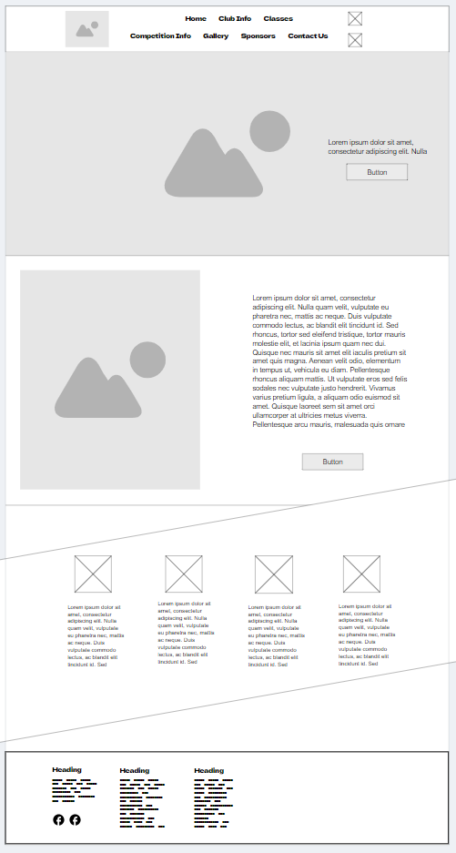

I started my wireframes by making a home page. Before I committed to making wireframes of the who whole website, I wanted to have the feel of the style of the website figured out, that’s why I only made the home page and would only wireframe the whole website when my client was satisfied with the home page. From the gut test I knew that my client really liked the bar that Northern Arena had on their website that stated some bullet points about them. Because of this I added a redesigned version of that banner. From the stakeholder questions I also knew that she liked when the social media links were in the navigation bar, so I did that. For the lander I added some text to the side and a button that takes you to another page.

### Iteration 2

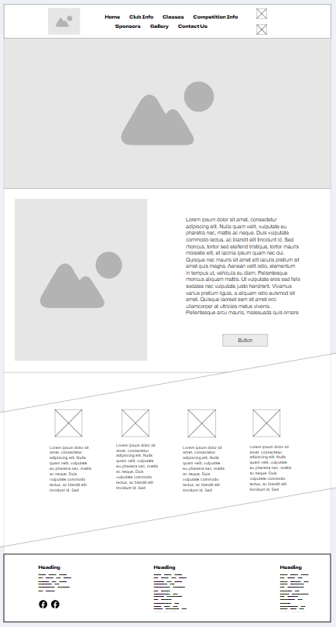

After showing her my first iteration she gave me some feedback. She said that she doesn’t like the button in the lander image. She also said that the header and footer look weird.   
I first started by getting rid of the button in the lander image. For the navigation bar I moved competition info to the top row so it looks more natural and as if it’s an arrow guiding you down to the rest of the website. For the footer, I decided to space out the 3 columns to give them some space to breath. This will also make the information more impactful as the user won’t feel overwhelmed.

### Iteration 3

After I made the changes to my previous wireframe, I showed my client the improved version. This time she said that she liked the new footer and agreed with my logic when designing it. She commented how she still doesn’t think the header looks quite right, and how for a home page this feels a little too short and lacking content.  
To fix the header, I decided to try and make it one row. While this does make it a little cramped, I think my client might like this more due to what she said on her gut test. To fix the empty home page I decided to add a few pictures at the bottom and a link to the gallery page.

## Iteration 4 – Final

### Home Page

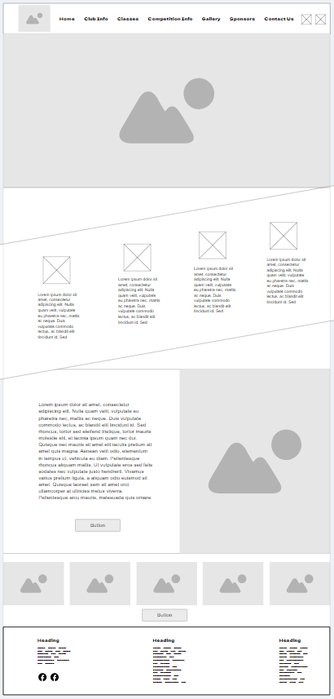

After showing my client the previous iteration. She said that it looks good and couldn’t think of any more changes that she would want to see. Even though she said that I still decided to experiment and swapped the location of the 2 middle sections around. I decided to do this because currently the bottom section was quite empty and lacked much info. I also think that the banner that shows bite size information is better at the start for people who don’t want to read much. After showing this to my client she said she liked it more than the previous iteration, so I decided to keep the changes. I couldn’t think of any other way to improve this wireframe and my client was satisfied so I decided this will be my last iteration and I’ll focus on making the rest of my website.

### Club Info Page

For this page I decided to start with information about the club at the start with a few photos. At the bottom I have 2 sections for photos of the coaches and a little about them. Underneath that I have the awards. Since I know that these awards aren’t too prestigious, I decided to keep them at the bottom. If in the future they win any awards that are really important to show off I can adjust the page to have awards more at the top. As it current is though, I like the way this page looks and so does my client.

### Classes Page

This page is the page that will have sign up for classes. They will fill in all their information and have a drop down to select what times they want. This page doesn’t have much but it’s just a form that will be sent to my stakeholder and they will be able to do everything from there.

### Competition Info Page

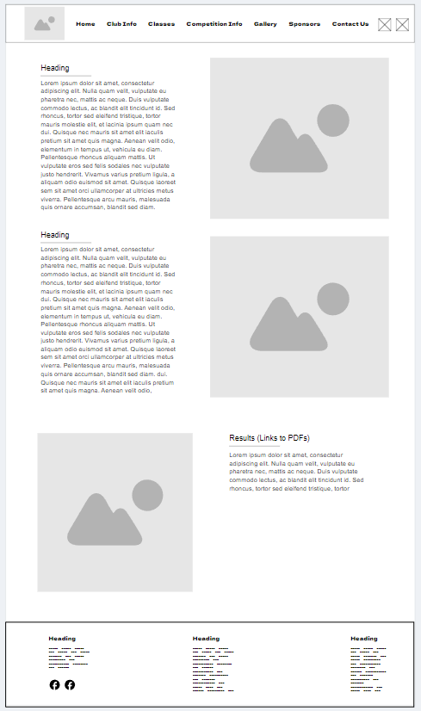

A lot of these pages don’t have anything technical except photos and information. Since that’s the purpose of website it’s not a problem but the design process behind each page isn’t really that complex. I put the information about the competitions at the top so that people can understand what a competition looks like and the rules for them. At the end I put the results to previous competitions. I did that so that people understood what goes into competing before they look at the results so that they don’t make wrong assumptions.

### Gallery Page

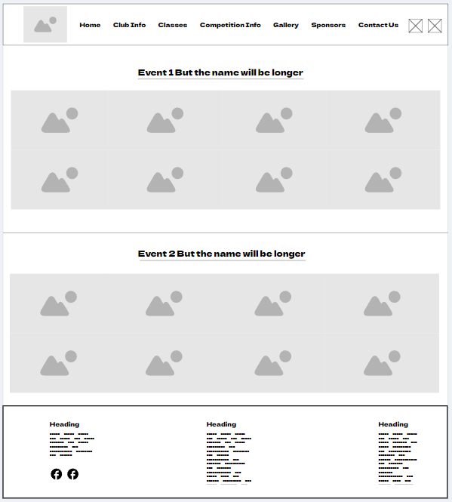

This is the gallery page. I have laid out as a rectangle with 8 same sized pictures but in the actual website the pictures will be different aspect ratios and sizes. Each gallery will be sorted into its own categories.

### Sponsors Page

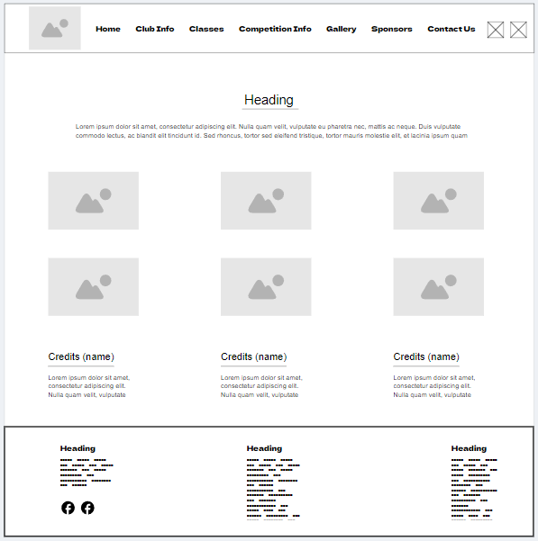

This is the sponsor’s page. The pictures will be clickable and will send you to the websites of the sponsor. My client has 5 sponsors and the person who made the logo has his own logo that will be the 6th picture. In the bottom I have credits for people who helped with running the club and make the website. Currently I only need 3 slots for credits (in stakeholder questions) so I only made three, but if I have to update the site later, I can add more rows.

### Contacts Page

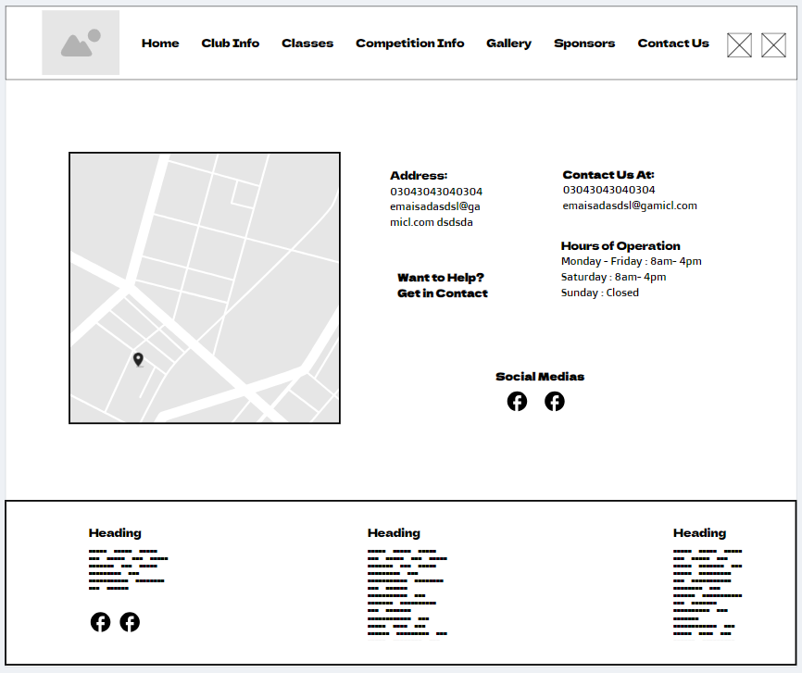

This is the contact’s page. It has all the basic info that you need about the club, organizers, and google maps that shows the location of the club.

## Mobile Wireframes

Example of navigation bar on phones

For my mobile wireframes I used my computer wireframes and made everything fit into a vertical screen. The hardest part of making mobile wireframes is deciding the navigation bar. Because a mobile screen doesn’t give you as much horizontal screen as a monitor, the amount to pages you can show in 1 line is very low. To overcome this problem, I will make a header with the club logo, social media links, and a navigation bar button. Once this button is pressed it will open a drop-down menu that lets you select which page you want to visit. Apart from that, I don’t have anything else to mention about my mobile wireframes, so I won’t give   
commentary on each one.

### Home Page

### Club Info Page

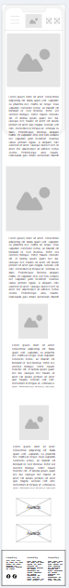

### Classes Page

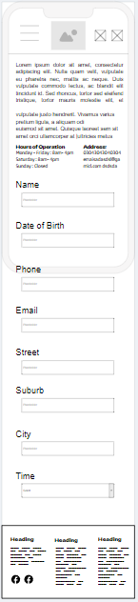

### Competition Info Page

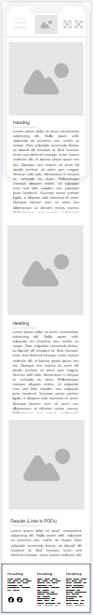

### Gallery Page

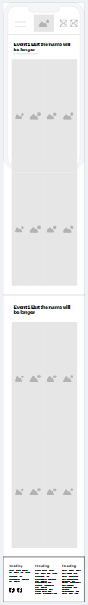

### Sponsors Page

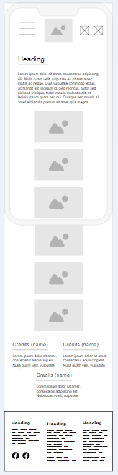

### Contacts Page

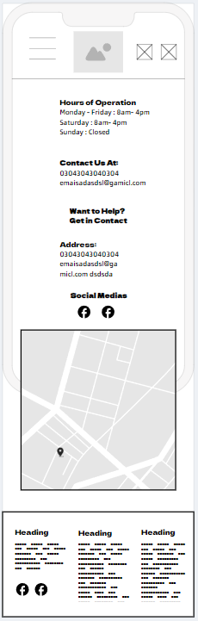

# Design Tiles

Design tiles are like a mood board for how your website will look like. Unlike a mood board however, it should have some structure to it. Your design tiles should focus on showing the visuals of the website more than the functionality of it. In your design tiles you should have a banner on the top, underneath you should have what the headers, sub-headers, and the paragraph text will look like, and somewhere on it you should also have the colours and some sort of way to find them (e.g. hexadecimal values.) Apart from those main features, you should focus to show off any other parts of your design that you think are crucial. This should all be done using the stakeholder’s input from before designing something that they would like. You should have 2 or 3 design tiles to make give your client choice. It’s important to ask for feedback on your design tiles and improving them until your client likes them. To make my design tiles I will use photoshop. I chose it because I have used it a lot in the past, I like the freedom it gives the designer, and I feel comfortable using it.

## Design Tiles 1

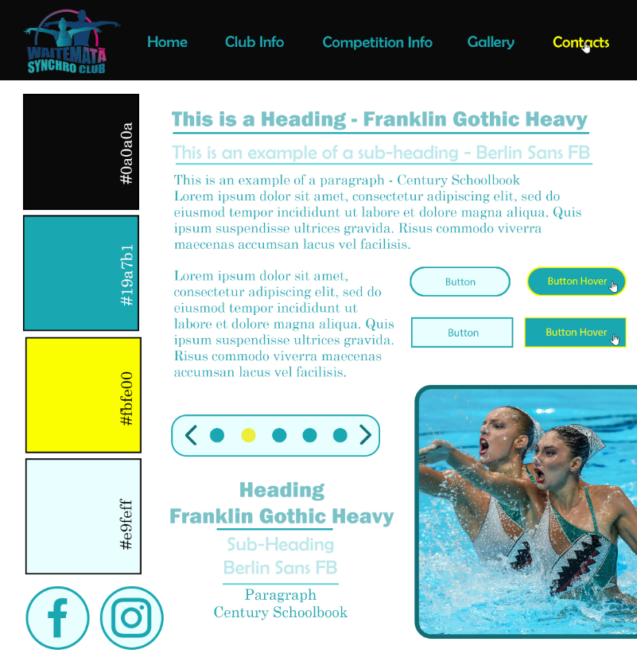

For my first design tile I decided to listen to my gut test and stakeholder questions and make something that is similar to the sites she liked. Making the header any other colour than black was really hard. The logo containing a lot of shades of blue and some shades of pink and purple really limits the colour selection I had. To add on top of that, the only colours that made the logo visible were really bright and stand out colours like red and bright yellow which didn’t go too well with the swimming website theme. The reason I went with yellow for one of the colours was because it’s almost the opposite side on the colour wheel than cyan, meanwhile also being close to it. For those who don’t know, opposite colours on the colour wheel are very unalike and stand out when used together. If used correctly, opposite colours can be used to make a unique and appealing look. Colours that are close on the colour wheel are more similar and easier to blend in together. Yellow being both an opposite and close it results in being a good colour that blends in and doesn’t stand out too much.

## Design Tiles 2

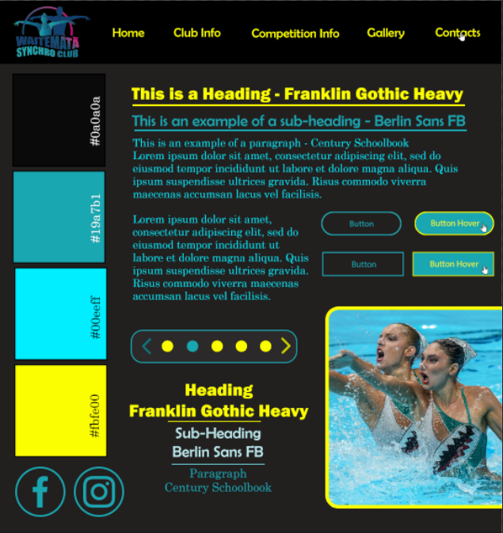

For my second wireframe I stuck with a similar design style but changed around the colours. This time I went with a black website instead of a white one. Having a black website meant that I could make more use of lighter colours such as light blue and yellow. However, after doing some studying, I have found that black websites make the pupil dilate and after a long time on a black website will cause a weird effect when you look at something bright and whiter. I’ll let my client know this beforehand so that she can think about the design and functionality of the site.

## Feedback

My client liked the first one more. She said that she thinks colours were used way better in the first one. The way I used yellow a lot less on the first one made it more important. In the second one the yellow stands out more but with how much it’s used it makes it feel over used. I forgot to change the colour of the hover navigation bar in the 2nd design tile but my client said that I couldn’t make it any sensible colour and make it stand out more than the yellow. She likes the navigation bar of the 1st design tile, the colours are good and likes the use of yellow when a page is hovered over. For the buttons she didn’t like the square ones. She said that the round buttons look way better and more in theme with everything else on the website. Overall, my client liked the first design tile way more so I will base my high fidelity on that one.

# High-Fidelity Wireframes

High-fidelity involves combing your wireframes and your design tiles. This is one of the final steps before you are ready to start coding your website. Ideally you shouldn’t have to make multiple iterations for this stage because you should have done that while making your design tiles and wireframes. However, sometimes your design in the design tiles looks worse on the wireframes or doesn’t match the pictures so you might have to do a few iterations.

Luckily my client liked my first iterations of my high-fidelity wireframes so I didn’t have to make more. One problem I experienced with moqups when making my high fidelity was that I could only upload 25mb worth of images onto the website. This made it so I could only upload only a few images. To overcome this, I did everything I could in moqups and then took a screenshot of it. After that I uploaded the screenshot to photoshop and added the pictures where they are meant to be. The only problem with this solution was that the images ended up being low quality. However, that’s alright since you can see the general look of the website.

### Home Page

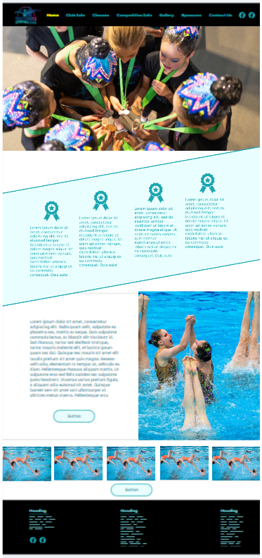

### Club Info Page

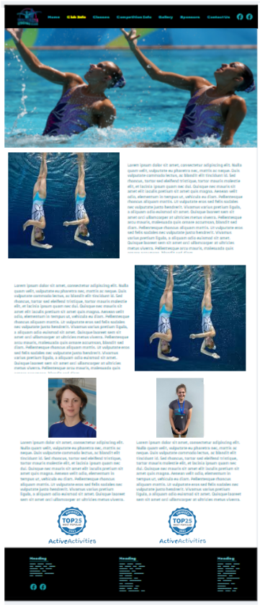

### Classes Page

### Competition Info Page

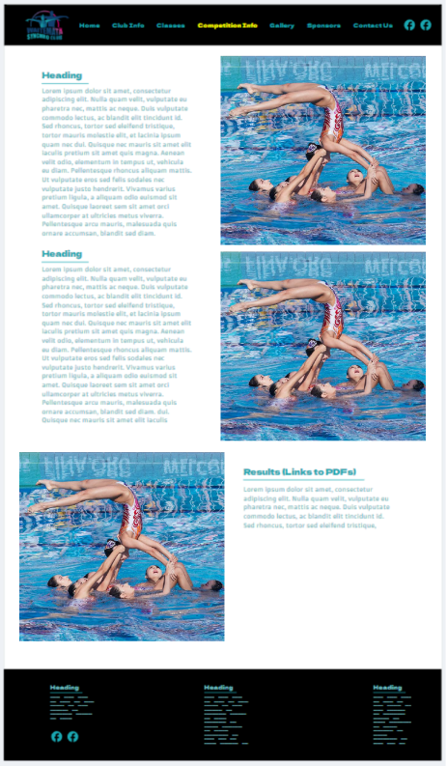

### Gallery Page

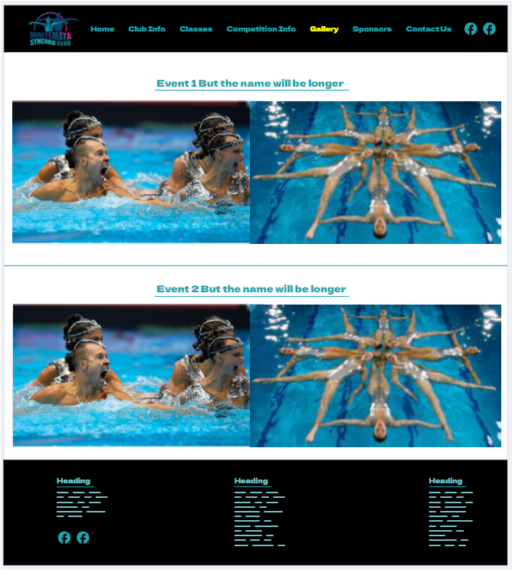

### Sponsors Page

### Contacts Page

## Mobile High Fidelity

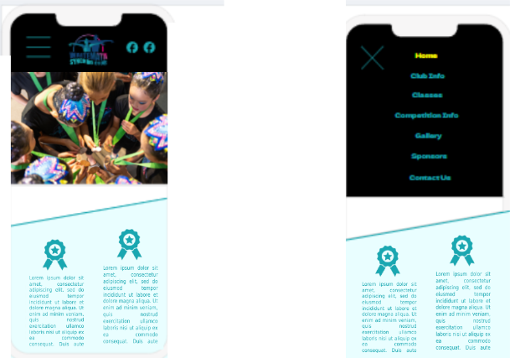

### Home Page

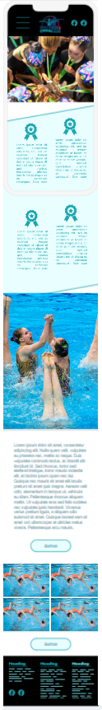

My stakeholder told me to move the picture in the middle down a bit when I make the website. Apart from that she liked the rest of them, so I won’t comment on them.

### Club Info Page

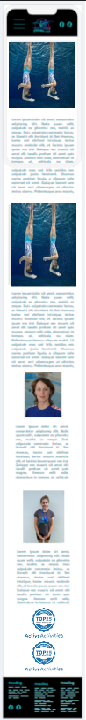

### Classes Page

### Competition Info Page

### Gallery Page

### Sponsors Page

v

### Contacts Page

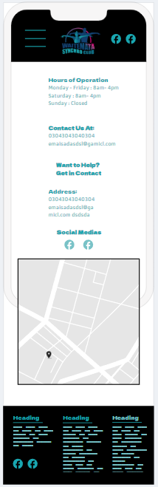

# Relevant Implications

## Legal

Legal means that we don’t break any laws with our website. The main law that we need to worry about is copyright. Copyright is an intellectual property that gives its owners the right to do whatever they want with their images, music, or videos. We need to respect copyright because if we use images that we don’t have the rights to, we could get contacted by the original owners and either get asked to take it down, asked to pay for rights to use it, or get sued by the original owners. To avoid copyright, I will only use images that my client herself has taken and has given me permission to use. Due to artistic swimming being an artistic activity, my client has lots of photos and she’ll them to me for use without me needing to worry about having to pay or being sued.

## Privacy

Privacy means that we don’t use pictures of anyone who hasn’t consented to being used. This means that if we have a picture of someone, we will have to ask for their permission. If we don’t ask for permission, we could see legal action, or the club/site might get a bad reputation make users less likely to want to interact with the club. I won’t have to worry about this because most of the pictures on the website will be off the club members performing (with intentions of being photographed / filmed.) However, just to be safe, my client will ask everyone in the photos if the are fine with their photos being used on the website. It’s important to remember that if someone is fine with one of their photos being used, doesn’t mean that they are fine with all photos including them. So you have to make sure you show them all the photos you are planning to use and see which ones they are fine with being used and which ones they are not.

## Usability

Usability refers to the website being easy for an average person to use and it being quick and efficient to do whatever you want. This means that we can’t use any icons or words that an average person won’t be able to understand. This also means that we have to make it obvious where you need to go to do to accomplish your goal. To do this, I will do quite a lot of things. One of these is putting useful information all over the site. For example, a lot of users would come to the website to see the club’s location, email, and/or the phone number to call. To make it easy to find all of these things I will include this information in multiple places like the footer, contacts page, and the about us page. I will also use widely known icons that everyone will understand, like the Facebook and Instagram logo. I will made it obvious on how to accomplish your goal by using the navigation bar effectively. If you want the contact information you should go to the contacts page. If you want to see previous competition results, you go to the results page.

# Evaluation

Throughout the development of my client’s website I have used a lot of different processes, tools, and UX methodologies. Now that I am done with the development of the website and ready to code the website, I wanted to look back on each process and evaluate them and see how useful they were.

## Stakeholder Questions

The stakeholder questions were really important to how I designed by website. Without stakeholder questions it would’ve been impossible for me to design a website that my client wants as I wouldn’t know what I need to make. The stakeholder questions helped me with picking the colours, the fonts, the layout, and also gave me insight on what features my client doesn’t want on the website. When making a website it’s good to know what your client wants, that is why you should always ask in-depth and open questions whenever making a website for someone.

## Gut Test

The gut test is another process that I think was really important. While the stakeholder questions can help me visualize a design, the gut test lets my stakeholder actually show me what they want in the design. The gut test helped me a during wireframes because I could include aspects of other websites (changed slightly however) that my client liked. Making the gut test itself was also good for me. I got to find look at websites and see how they categorize and display their content. There are some ideas that helped me make my wireframes that I found on my own without my client’s feedback on it. Doing my gut test also helped me find website for my competitive analysis.

## Competitive Analysis

This was somewhat important. However, if I was under a big time crunch, this would be the second thing that I wouldn’t do to save time. I liked looking at the websites themselves like I explained for the gut test. Looking at the Northern Arena gave me a lot of insight on how not to make my website. Competitive analysis also helped me with think about the contents of my website and decide what I do and don’t need.

## User Personas

This UX methodology is probably my first thing that I wouldn’t do to save time. Initially when I was researching and writing about user personas at the start of this visual diary, I thought they would be pretty useful. However, after making them I have changed my mind on their usefulness, at least for a solo developer. Due to the fact I’m the only person working on this website, I think talking to the people who will use this website was more helpful than making user personas. As it is, I basically just condensed all the people I saw and wasted time making up their frustrations and wants. I think the time I spent on making the user personas could’ve been spent better on other school projects or studying. I see how user personas could be helpful on a team with more than 1 person. However, for me they were just a waste of time and an annoyance to make. Lucid charts felt really good to use however, which meant that I didn’t spend too much time trying to make them.

## Card Sort

Unlike user personas, I think this was the most beneficial UX methodology. I really liked this methodology since it helped greatly with what pages I have and what info I put on them. It was also insightful to see how people categorize information.

## Other UX methodologies

There’s some UX methodologies that I researched and wrote about but didn’t end up doing. The first one was journey mapping. I talked about why I didn’t like when I explained it. The fact that you spend so much time of thinking and showing hypothetical things that I could just write down on a piece of paper makes me believe that this would’ve been a big waste of time. That is why I didn’t do journey mapping.

Another Methodology I didn’t do was empathy mapping. Same reason as the journey mapping, it takes too much time and effort making something that doesn’t apply to the website much.

The final methodology I didn’t do was a user survey. My reasoning for this is that I think it would be better used when I finish coding the website and want feedback from customers on how to make it better. Since as of this moment I’ve only conceptually finished this website, I do not need a user survey. However, I might end up using it later when I finish coding my website.

## Design Tiles

I always like making design tiles. I like making a design for a website that is aesthetically pleasing and uses colours well. This is one of the more fun aspects of making a website in my opinion. On top of that, they are also really helpful for making my website. Design tiles help me pick what colours and fonts I want to use for high fidelity. I faced a problem while making my design tiles where my school’s adobe subscription got cancelled and I couldn’t finish them. Thankfully I was able to do a 7-day free trial that I used to finish my design tiles and high fidelity.

## Wireframes

Wireframes are another really important tool for making a website. Coding a website without wireframes would take a bunch of time and effort due to having to write new code whenever you don’t like the design. Wireframes let you experiment and mess around with the layout of your website without having to write any code. High-fidelity wireframes help me as they give me the goal of what my final website should look like when it’s fully coded. When making my high-fidelity wireframes I encountered a problem where the website I was using could only have 25mb of photos stored on it. This was a problem as I could only upload 2 pictures before it told me to buy a subscription. To overcome this problem, I did everything that I could on the website and when there were only the pictures left, I would take a screen shot using snipping tool and put it into photoshop. From there I would add the pictures and show the finished product to my client. This did have the negative effect of making the placeholder text really blurry but that is fine since the main point of high-fidelity is to see if your colours and fonts look good when used in a website.

## Overall Evaluation

Something that I struggled with when making this was the time limit. My teacher cut down the assignment time from 1 term to the end of week 7 which gave me 4 weeks less to work on this assignment. To add on top of this I too write an essay and a report for English and Physics. This led me to having to stay up quite a lot and lose some hours of sleep. This did get easier once I swapped my DVC (architecture) class for ILP (free study period) but I still had to stay up quite a bit.

# Future Developments

If I had more time to develop the Waitemata Synchro Club website I would make an account system and make signing up be fully doable online. The way that I have designed the website right now requires my client having to call and confirm the lesson with the customers. If I had an account system, I could make it so that she only has to call each time someone makes an account to confirm it isn’t a troll account. The current way I have done it trolls can book fake classes and not show up to them, this is why calling them is required. As it is though, I didn’t have enough time to design this. This also requires coding knowledge that I don’t have and will take lots of time to make when I come around to coding this website.

Another thing I would’ve done if I had more time was add a news page. When doing my competitive analysis, I noticed that all the sites (except the smallest one) have a news page. This is a pretty good feature to have but since my client didn’t ask for it and didn’t comment on it during the gut test, I figured she didn’t want a news page. With extra time I could’ve experimented with the idea and see what my client thought about it.

One more thing I would do if I had more time would be ask random people about their thoughts on the final high fidelity. Asking the future client base for way to improve the site would make them more likely to use the site and interact with the community later. While I focused on making a website that my client likes, it would’ve been also wise to see what the actual clients think of it.

# End-User Consideration

The end user consideration is the consideration of the end user when you are making your final product. This should be done through-out at all the steps of the design process to make a product that will satisfy the user’s wants and needs. At the very start of my project, I researched lots of UX methodologies to understand the processes that I would need to use to make an outstanding website for my client.

The first thing I did to think about the end user was making the User Personas, card sort, and meeting with future users of the website. To make the user personas and for people to do my card sort I went to one of my stakeholders coaching lessons where afterwards I talked to some future users (e.g. parents and club participants) and got to know who they are, how they interact with technology and what they like and don’t like in other websites. This let me make my user personas which were based on the people I talked to. Making the user personas helped me list some frustrations future users might have and made me consider how I would make a website that avoids those problems.

The card sort helped me consider where users will try to find information. By letting the future users help me with sorting information it will ensure that less people don’t find the information they are looking for. This also makes the users feel like they were part of the website, making them feel good about themselves and they’ll be more likely to use the website.

For my design tiles I considered my end-users when choosing the colours. Since my end-users are more likely to be social and energetic people, I made the main colours be bright and light as they are seen as more energetic and social colours.